**4.STORED PROCEDURES**

**Exercise 1: Create a Stored Procedure**

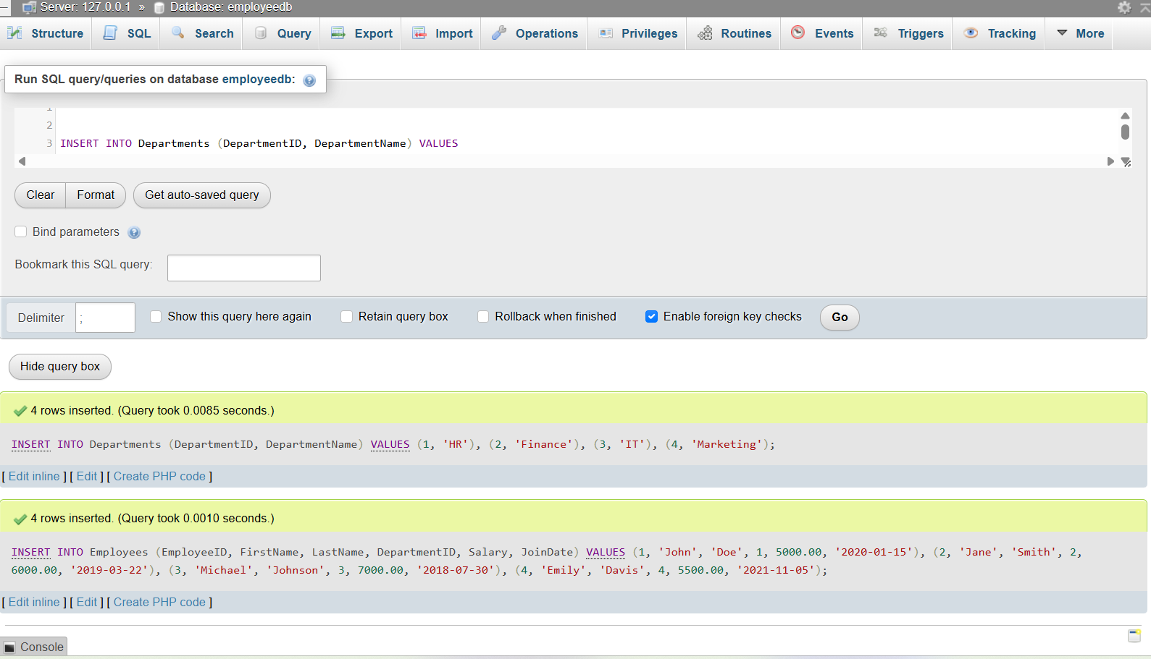

1.Define the stored procedure with a parameter for DepartmentID.

DELIMITER //

CREATE PROCEDURE GetEmployeesByDepartment(IN deptId INT)

BEGIN

SELECT * FROM Employees

WHERE DepartmentID = deptId;

END;

//

DELIMITER ;

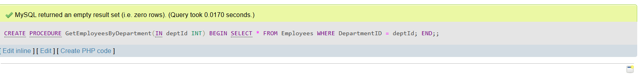

2. Write the SQL query to select employee details based on the DepartmentID.

CALL GetEmployeesByDepartment(2);

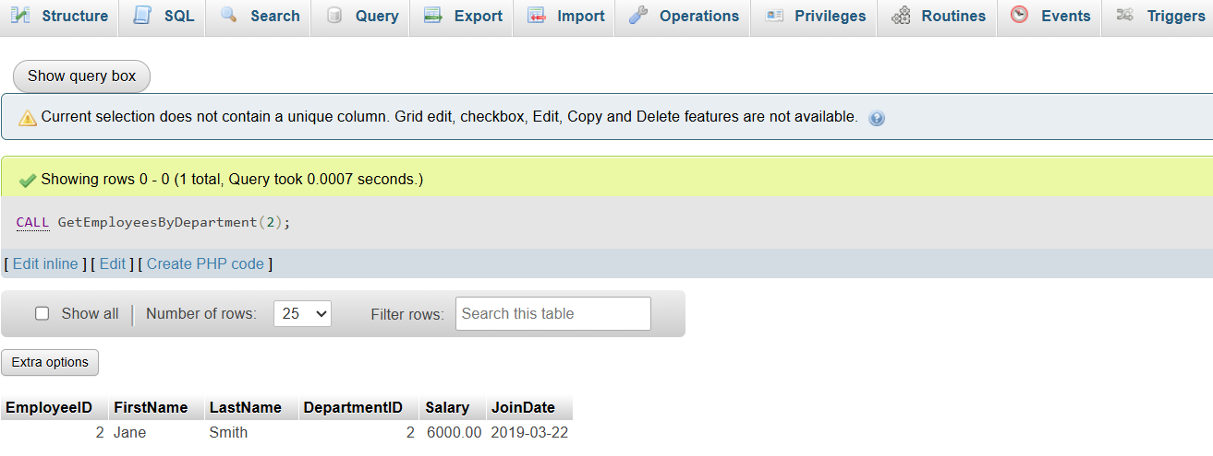

3.. Create a stored procedure named `sp_InsertEmployee` with the following code:

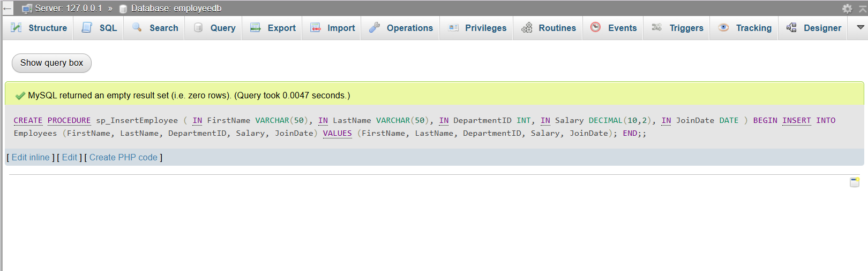

**Exercise 5: Return Data from a Stored Procedure**

1. Define the stored procedure with a parameter for DepartmentID**.**

2. Write the SQL query to count the number of employees in the specified department.

3. Save the stored procedure by executing the Stored procedure content.

DELIMITER //

CREATE PROCEDURE sp_CountEmployeesByDepartment(

IN dept_id INT

)

BEGIN

SELECT COUNT(*) AS TotalEmployees

FROM Employees

WHERE DepartmentID = dept_id;

END;

//

DELIMITER ;

